**CRIMINAL NAVIGATION PROJECT**

**Problem Statement- Extract Geo Location/Criminal Navigation Using Mobile/Email base Tracking System**

**Solution -** This portal facilitates criminal navigation for police, through location tracking in both online and offline mode using which precise location of the criminal can be accessed. We are capable of tracking call & message records of a suspicious criminal, without intimating them and also keeping the details hidden.

We have prepared two apps to supervise the criminal activities in the area. One for the police and the other for the criminal. Here are the lists of features in the app.

|  |  |
| --- | --- |
| Features of Police App   1. Criminal Tracking 2. Criminal Details 3. Biometric Authentication Info to be send   Common Features of Both   1. Heat Map 2. Criminal Statistics 3. SOS   Features of Passive Aggressive   1. Face Recognition 2. On click location tracking | Features of Criminal App   1. Biometric Authentication 2. 360® View Authentication 3. Tracking 4. SOS   Dependencies   1. Phone 2. Google maps services 3. Google firebase 4. Google play services |

**Face Recognition –**

If we have the photo of the criminal, we can find out the social media accounts in which the photos are uploaded. These are the following steps:-

**Step 1- Finding all the faces**

1. The first step is face detection.
2. We make the picture black and white as we don’t need the colours.
3. We look at every single pixel in our image at a time. Our goal is to figure out how dark the current pixel is compared to the pixels directly surrounding it.
4. We end up with every pixel being replaced by an arrow. These arrows are called ***gradients***.

**Step 2- Posing and Projecting Faces**

1. We pick out unique features of the face that you can use to tell it apart from other people— like how big the eyes are, how long the face is, etc.
2. we use an algorithm called face landmark estimation.
3. The basic idea is that we can take 68 specific points (called landmarks) that exist on every face — the top of the chin, the outside edge of each eye, the inner edge of each eyebrow, etc.

**Step 3- Encoding Faces**

1. The neural network learns to reliably generate 128 measurements for each person.
2. Machine learning people call the 128 measurements of each face an **embedding**.
3. The training process works by looking at 3 face images at a time:
4. Load a training face image of a known person
5. Load another picture of the same known person
6. Load a picture of a totally different person

**Step 4-Finding the person’s name from the encoding**

1. All we have to do is find the person in our database of known people who has the closest measurements to our test image.
2. We train a classifier that take the measurements from a new test image and tells which known person is the closest match.

**On-click Location Tracking-**

We will send a link to the criminal’s phone via email or via phone number. As soon as the criminal clicks on the link he will be redirected to the website, but in the background we will get their location, but only after he clicks allow on the location permission asked by us.

The criminal may or may not allow the location if he will allow we will get the location immediately. But if he chooses not to allow we can add some features where he can reply to us by that means we can access the location.

**Login –**

The user login and the police login are two different parts of the same app. They both sign up with a username and password and receive an OTP for the authentication.

Through police login features like Biometric authentication information to be sent, Criminal details and reports are the unique features. All the other features like SOS, Heat Map, and Criminal Statistics are the common to both the apps.

**Heat Map –**

It illustrates the sensitive areas of high crime rates and the low crime rates. Red being the highest and green being the lowest. The heat map uses the firebase database to retrieve the location to pinpoint it on the map and shade the region which is affected higher.

Women’s security is also ensured as it shows which areas are highly affected and which are safe for them.

**Location Tracking –**

We take the location from the GPS, if there is internet connection the location will automatically be updated in the fire base. But if there is no internet connectivity, all the locations will be stored in the file, which will be uploaded once the internet connection is made. Both the apps use the same database firebase, from criminal app we upload the location to the firebase and from police app we retrieve the location to locate the criminal.

Withoffline maps, your phone uses its built-in GPS radio (which works independently of your data plan) to figure out where you are, then simply plots your route on a map that's stored in your phone's memory.

**Call and Message Tracking-**

Calls and messages will also be tracked of the criminals. If a criminal calls a particular number many times and police finds it suspicious , they can take appropriate action against the criminal.

**Excel Sheets-**

Details of the criminal and authentication Information will be shown in the form of excel.

**Crime Statistics –**

These are the stats presented by the police about the crime rate. All the users can see the stats. It is appeared in the form of bargraphs in our app.

**Biometric Authentication –**

Biometric authentication is a security process that relies on the unique biological characteristics of an individual to verify that he is who is says he is. Biometric authentication systems compare a biometric data capture to stored, confirmed authentic data in a database.

The police asks for the authentication of the criminal at a time, this solely depends on the police on which time he should ask for the authentication. The criminal gets the notification and responds with authenticating with the fingerprint. If the fingerprint matches the one in database, we consider the criminal is there where he says he is.

If not, he becomes a suspected person in the crime and the police can retrive the whereabouts of criminal.

**Criminal Details –**

These are the details of the criminal stored by the police force in the firebase through app. These contains the profile of the criminal name age height all the previous crimes committed, his present whereabouts, his previous living condition if any. Also the police add the criminal’s fingerprint for the authentication process.

**SOS –**

The SOS features are for the peoples who are in distress. It acts as panic button which alerts the police about the crime that has just happened in a locality. The SOS button gets the location of the phone from where it was pressed. The police gets the notification and the location so that they can act upon it

**Website-**

We also provide a web based service for admins and police to provide an even easier way to view and manage criminals and other accounts.

Here the admins can create new police accounts or process requests by police, like changing a criminal if necessary or to access records outside their teritory. The police will be able to add new criminal records, and view them along with heatmap.

We are also generating csv records of criminals on daily basis. Police will also be able to see crime statistics.

**WORKING PROTOTYPE**

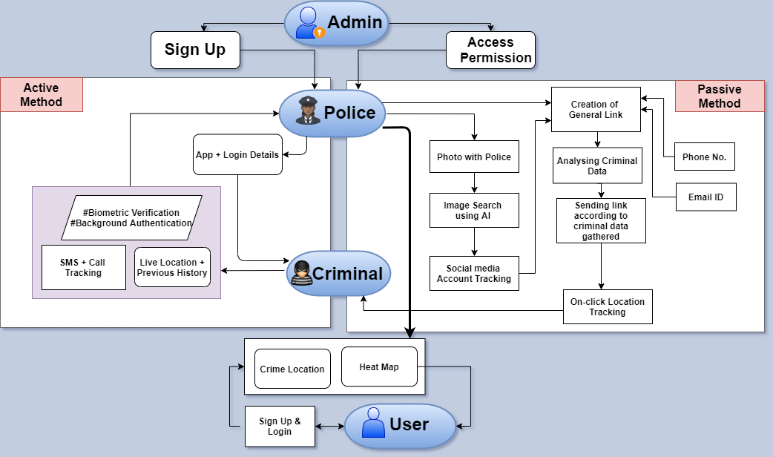

**TECHNOLOGY STACK**

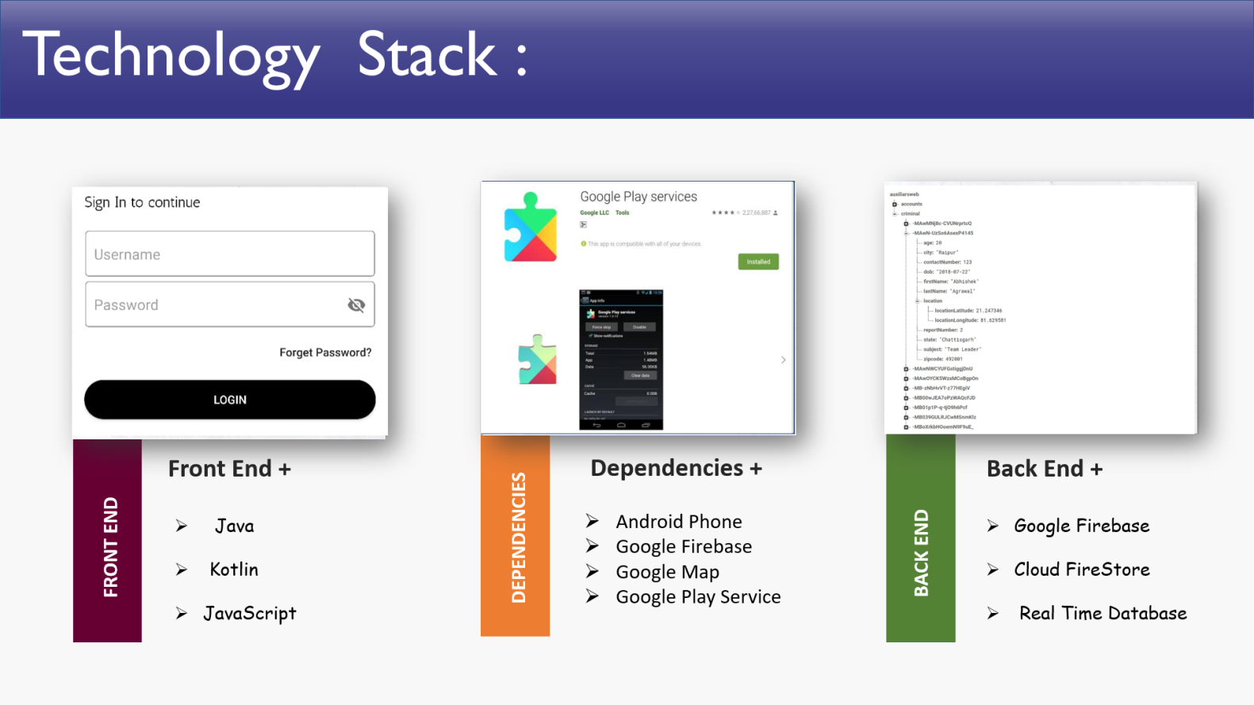

**TECHNICAL COMPONENTS**

1. **Firebase –**

|  |  |
| --- | --- |
| Introduction | Firebase is Google's mobile platform that helps you quickly develop high-quality apps. |
| Real time database | It lets us store and sync data between our users in realtime. Realtime syncing makes it easy for your users to access their data from any device: web or mobile. |
| Offline Support | Cloud Firestore caches data that the app is actively using, so the app can read, write, listen or query even if the device is offline. When the device comes back online, Cloud Firestore synchronizes any local changes back to Cloud Firestore. |
| Cloud messenger | Firebase Cloud Messaging (FCM) provides a reliable and battery-efficient connection between your server and devices that allows you to deliver and receive messages and notifications on iOS, Android, and the web at no cost. |
| Authentication | It provides an end-to-end identity solution, supporting email and password accounts, phone auth, and Google, Twitter, Facebook, and more. Firebase UI provides a customizable, open source, drop-in auth solution that handles the UI flows for signing in users, which can maximize sign-in and sign-up conversion for the app. |

1. **Android Studio –**

|  |  |
| --- | --- |
| Introduction | It is the official integrated development environment for Google's Android operating system. It provides the fastest tools for building apps on every type of Android device |
| APK analyzer | Using the APK Analyzer can reduce the time we spend debugging issues with DEX files and resources within your app.  It also helps in reducing your APK size. |
| Android Emulator | The Android Emulator simulates Android devices on your computer so that you can test your application on a variety of devices and Android API levels without needing to have each physical device.  You can simulate incoming phone calls and text messages, specify the location of the device, simulate different network speeds, access the Google Play Store, and much more. |
| Android Profiler | The Android Profiler tools provide real-time data to help you to understand how your app uses CPU, memory, network, and battery resources. |
| Flexible Build System | The Android build system compiles app resources and source code, and packages them into APKs that you can test, deploy, sign, and distribute. It’s flexibility enables you to perform custom build configurations without modifying your app's core source files. |

1. Programming Languages –

|  |  |
| --- | --- |
| Front End | JAVA |
| Back End | JAVA |
| Website | JAVASCRIPT |

**USE CASE**

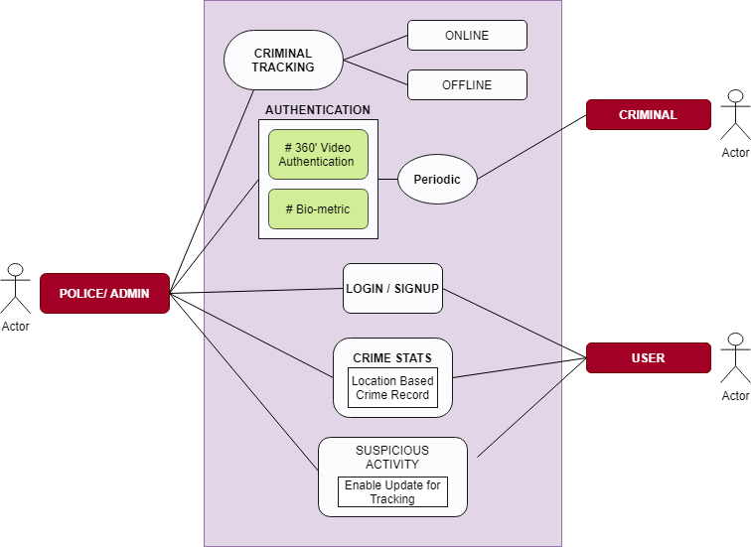

**MARKET RESEARCH**

1. **ExTra—**

The facial recognition and geolocation based application ExTra (Externees monitoring and Tracking system) is a spin-off of the Home Quarantine Tracking System (HQTS) used initially by Pune police and all Maharashtra police to monitor the people who have been asked to remain in home quarantine.

This is app is used by Pune police for the externed criminals. The tracking system keeps an eye on these criminals and sends an alert message if the criminal enters the externment region.

The person’s selfie, associated geo-location and time of attendance is tracked through Artificial Intelligence algorithms

**SIMILARITIES-**

1. This app also uses criminal authentication by asking the criminal to send a selfie once in a day, which will be geotagged, which will confirm the location of the criminal.
2. It also keep the criminal records of the externed criminals.
3. If the criminal fails to give the attendance, police will take strict action.

**OUR APP HAS—**

1. This app solely focuses on externed criminals whereas our focuses on all types of criminal including the externed criminals.
2. We use biometric authentication which will be asked once in a day randomly.
3. **CCTNS—**

The Crime and Criminal Tracking Networks and Systems, abbreviated to CCTNS, is a project under Indian government for creating a comprehensive and integrated system for effective policing through [e-Governance](https://en.wikipedia.org/wiki/E-Governance). The system includes nationwide online tracking system by integrating more than 14,000 police stations across the country.

**SIMILARITIES-**

1. Both apps will keep track of the criminal records. All the FIRs will be digitalized
2. Make the Police functioning citizen friendly and more transparent by automating the functioning of Police Stations.
3. sharing of Information among Police Stations, Districts, State/UT headquarters and other Police Agencies.

**OUR APP HAS-**

1. our app tracks the criminal physically through GPS online and offline both.
2. We use biometric authentication which will be asked once in a day randomly.
3. We also passively track the criminal’s location

**COST OF THE APP**

We are calculating the cost of app for 2Lakh police force per month

1. Authentication-

If we say that every day every police authenticate 4times a day then the cost will be 4.5Lakh.

1. Hosting-

Cost per month will be 4000.

1. Map API-

If we say that every day every police force authenticate 2times a day then the cost will be 90,000

1. Criminal Data-

This is the initial cost for 1.5 crore criminal details if we take one detail to be of 5-7MB. It is 1.5 Lakh

So per month our app cost will be **minimum 3000 per month per 1000 police force**, along with the initial cost of 1.5lac for data.